Hoisting the Flag (Blog Post)
Every morning, during summer camp, the youngest boy scout has to hoist a flag to the top of a flag pole.
- Explain in words what each of the graphs below would mean.
- Which graph shows this situation most realistically? Explain.
- Which graph is the least realistic? Explain.
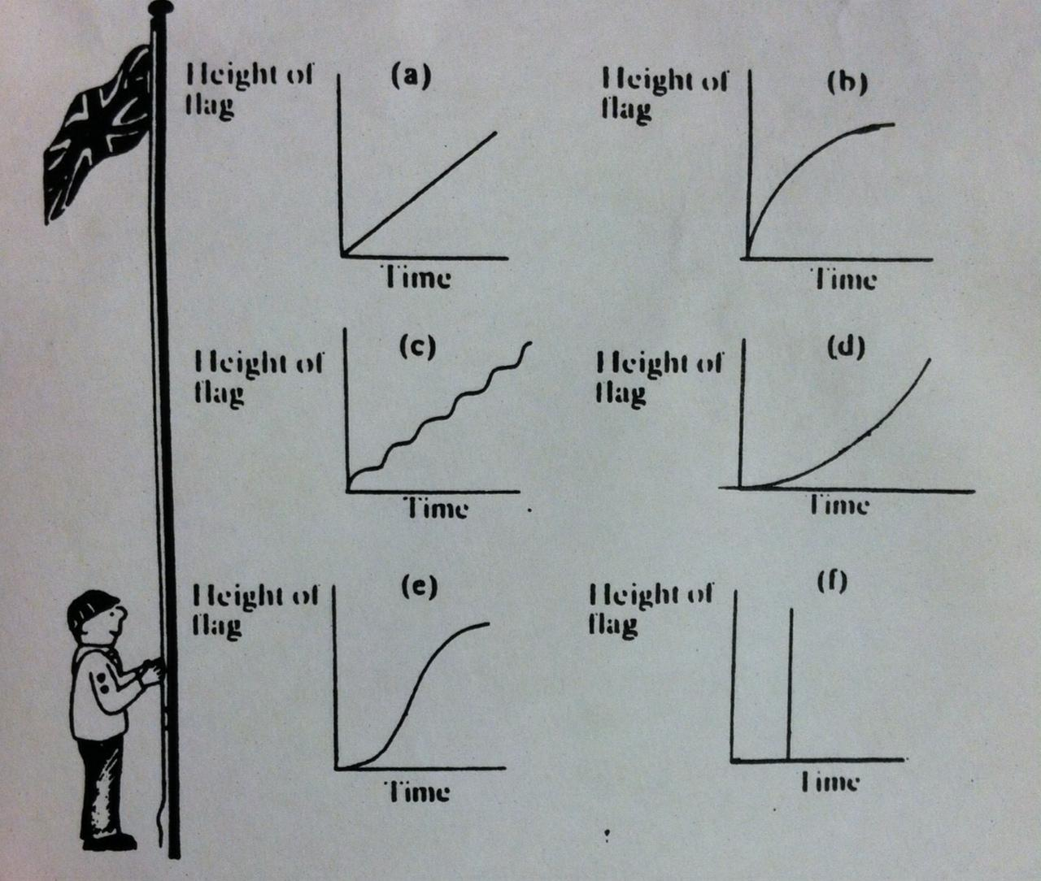

a. In this graphic the youngest boy scout hoist the flag consistently in height and time.
b. In this graphic the youngest boy scout hoist the flag at the beginning faster than at the end.
c. In this graphic the youngest boy scout hoist the flag stopping periodically in a height for some time.
d. In this graphic the youngest boy scout hoist the flag at the beginning less fast than at the end.
e. In this graphic the youngest boy scout hoist the flag at the beginning less fast than at the end where
he stops for some time.
f. In this graphic the youngest boy scout hoist the flag to the top of the flag pole without changing of time.

2. a. Because the boy scout hoist the flag consistently to the top of the flag pole.
3. f. Because it is impossible that the flag reaches without the passing of time.

